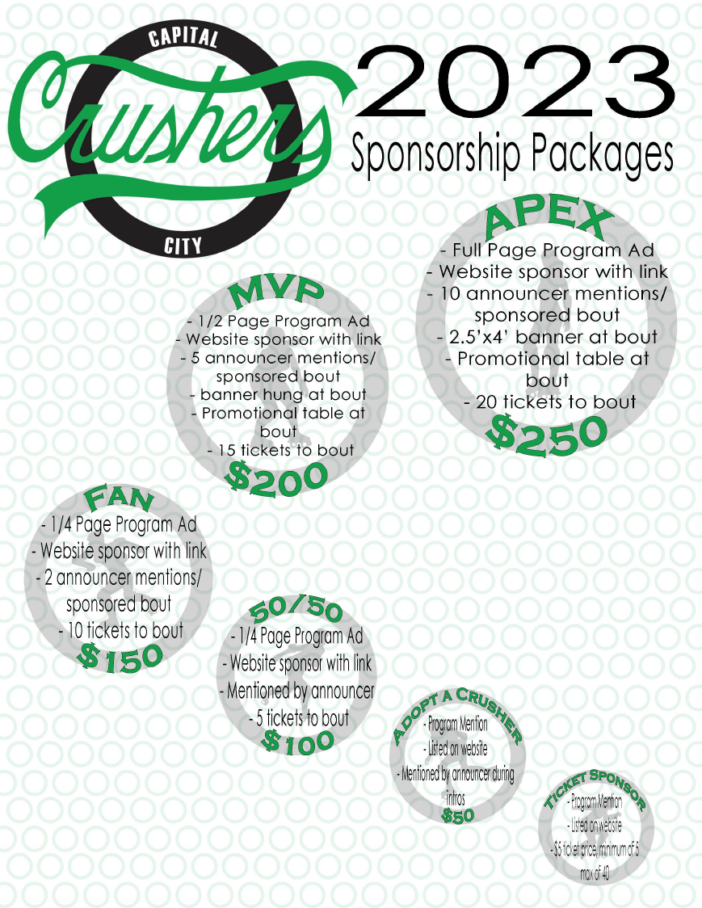

CAPITAL CITY CRUSHERS
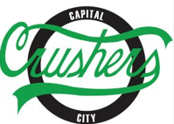
SPONSORSHIPS

ADOPT A CRUSHER $50
This package includes your name being announced during our game introductions! Your name will also be listed in our game programs and our online sponsor page.

50/50 SPONSOR $100
With this package you’ll receive 5 tickets to the sponsored game, and your name will be announced during our 50/50 raffle! You’ll see your name and logo in our bout program (1/4 page), and you’ll be added to our website sponsor page with a link to your choice of website.

FAN $150
You’ll receive 10 tickets to the sponsored bout, and your name will be announced twice during the bout! You’ll see your name and logo in our bout program (1/4 page), and you’ll be added to our website sponsor page with a link to your choice of website.

TICKET SPONSOR -$25-$200
This package is for businesses only-use these tickets as a giveaway through your establishment to employees or customers while simultaneously supporting our team! The minimum purchase is 5 tickets for $25. The maximum is 40 tickets for $200. Any range in between is welcomed! These tickets will be labeled not for resale. We will place your business name on both our bout program and on our website as a sponsor.

MVP $200
This package includes 15 tickets for the sponsored bout and your name will be announced 5 times during the game. We will have a banner with the logo and name of your choice hung during the bout and a table will be available for you to promote or sell items. You’ll see your logo and name in our bout program (1/2 page), and you’ll be added to our website sponsor page with a link to your choice of website.

APEX $250
Our most luxurious package includes 20 tickets to the sponsored bout, and your name will be announced 10 times during the game. We will have a banner with the logo and name of your choice hung during the bout and a table will be available for you to promote or sell items. You’ll see your logo and name in our bout program (full page), and you’ll be added to our website sponsor page with a link to your choice of website

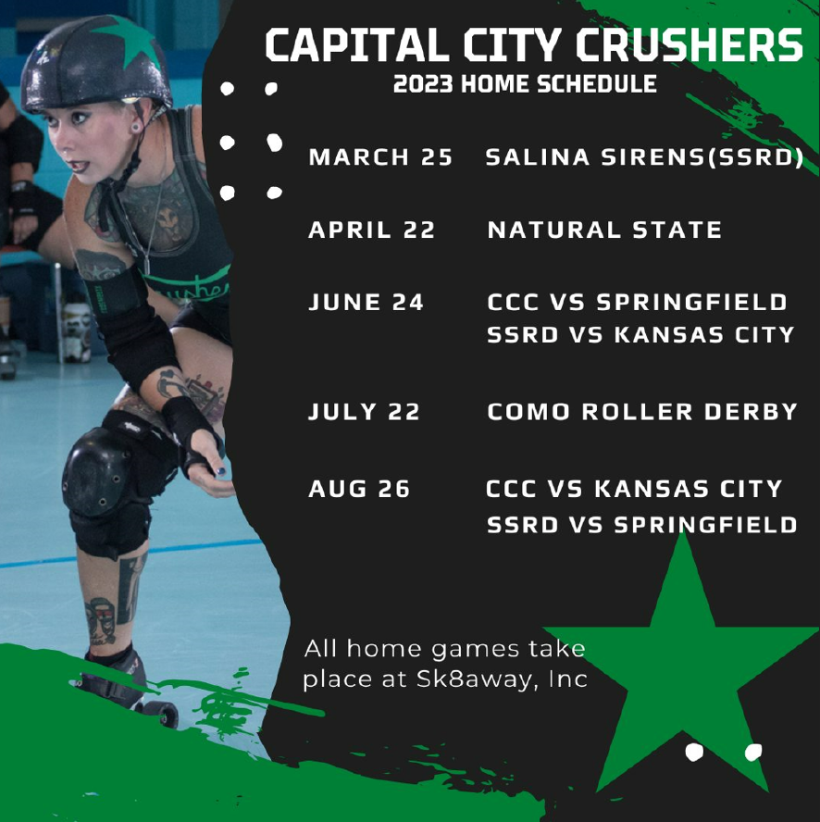

THANK YOU FOR YOUR SUPPORT!
Contact Information
Company Name
Contact Person
Phone
Email
Address

Sponsorship Package:
Date of Bout Sponsoring (if applicable)
Level of Sponsorship chosen (see below for options)
Payment Method
(We accept Cash, Check and PayPal: crusherstore@hotmail.com or search Capital City Crushers)
Additional Comments

- Apex - $250
- MVP - $200
- Fan - $150
- Ticket Sponsor- $25 to $200
- 50/50 Sponsor - $100
- Adopt-a-Crusher - $50 (only package for all season 2023)

Total Cost: Sold by:

Signature: Date:

CCC Contact Information
Email: capitalcitycrushers@gmail.com
Website: capitalcitycrushers.org
Facebook: Facebook.com/CapitalCityCrushers

